**<<Thu thảo store>>**

**Software Requirement Specification**

– HCM, Mar 2023 –

**Table of Contents**

I. Overview 3

1. Introduction 3

2. System Functions 4

3. Common Requirements 5

II. Functional Requirements 6

1. <<Feature Name 1>> 6

a. <<Function Name 1>> 6

b. <<Function Name 2>> 6

2. <<Feature Name 2>> 6

# Overview

## Introduction

My project is about a website selling phones called Thu Thao Store. My website provides a number of functions to help users and administrators can make purchases and management more convenient and faster.

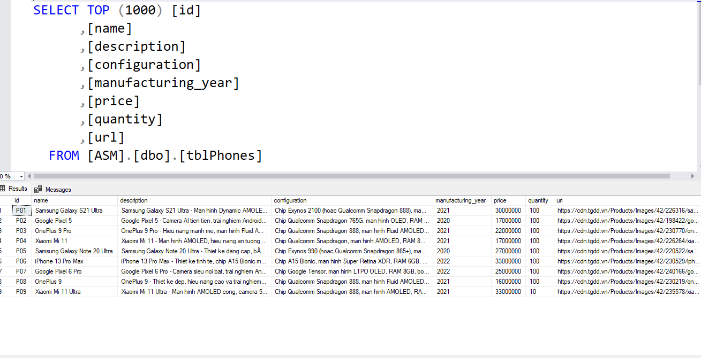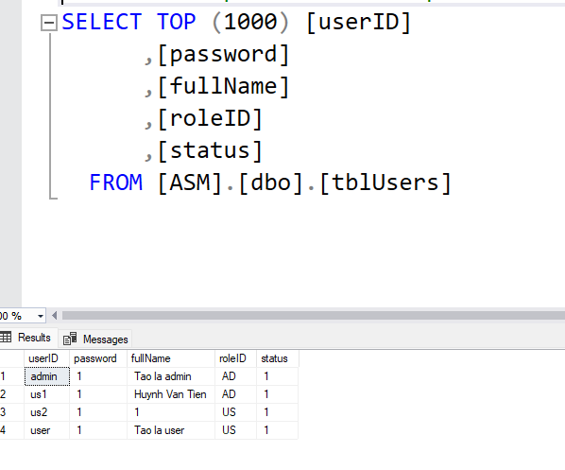

1. **System Functions**

#### a. Screen Flow

*[This part shows the system screens and the relationship among screens. You can draw the Screens Flow for the system in the form of diagram as below]*



#### Screen Details

*[Provide the descriptions for the screens in the Screens Flow above]*

|  |  |  |  |
| --- | --- | --- | --- |
| **#** | **Feature** | **Screen** | **Description** |
| 1 | Get list of milk tea | Home Page | List of milk tea |
| 2 | Get milk tea detail | Product Details | Contains milk tea details about phone information, configuration ,manufacturing year, select quantities, add to cart button |
| 3 | Login account | Login page | Contains text box to input username and password, login button, register button. |
| 4 | Register account | Register page | Contains text box to input user information, register button |
| 5 | Check out | Check out page | Click button check out |
| 6 | Buy product | Confirm product | Contains user’s information, quantities , price, check out button. |

# Functional Requirements

## Login

* Function trigger: after clicking login button.
* Function description: The system allows users to use their username and password to log in to the website.
* Screen layout:

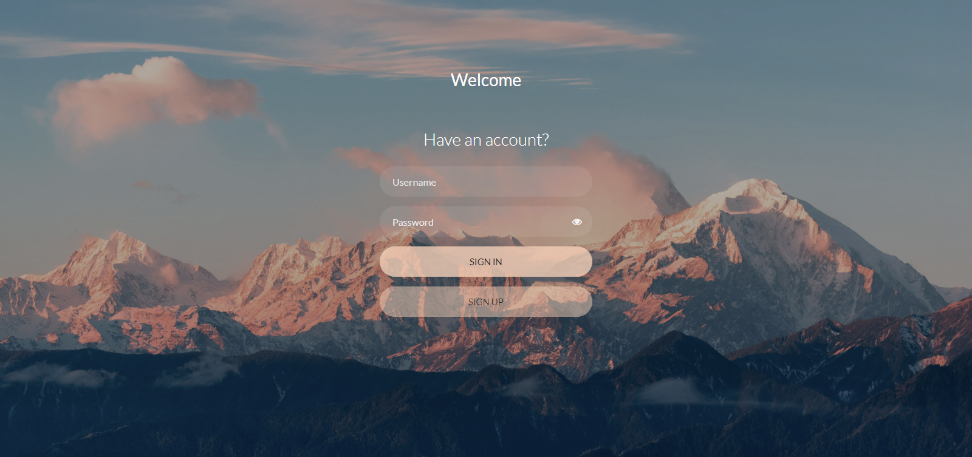

1. **Register**

* Function trigger: after clicking register button
* Function description: The system allows users to register for an account
* Screen layout:

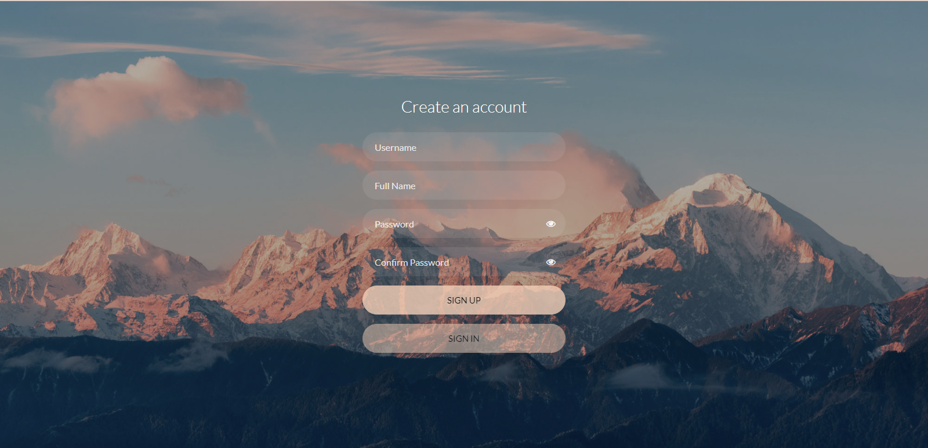

## Show homepage

* Function trigger: after the clicking “Home” link or homepage tab
* Function description: the system shows the homepage for user
* Screen layout:

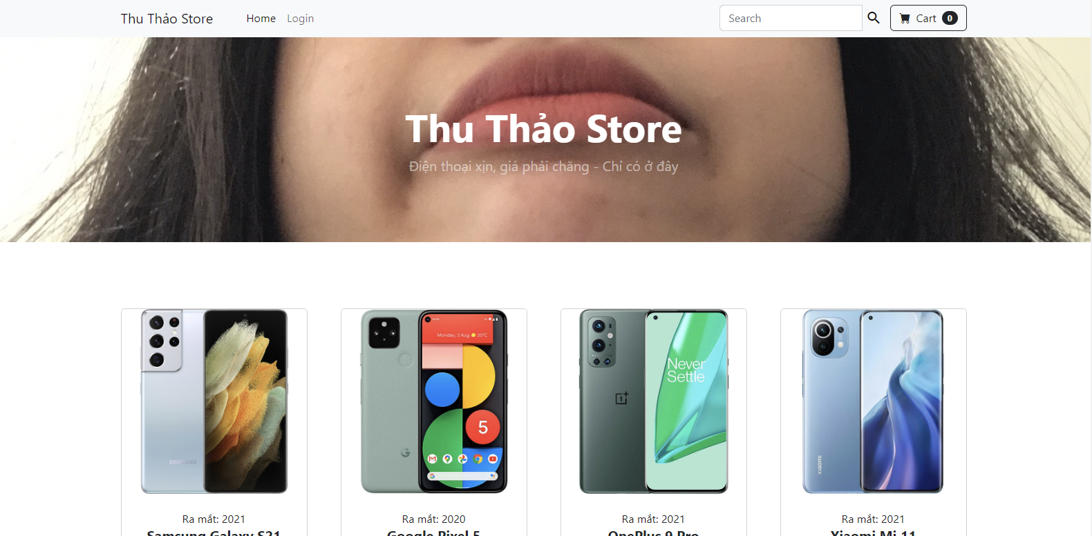

## Search products by name

* Function trigger: after type name of products and clicking search button
* Function description: Display products tea according to user’s search request
* Screen Layout:

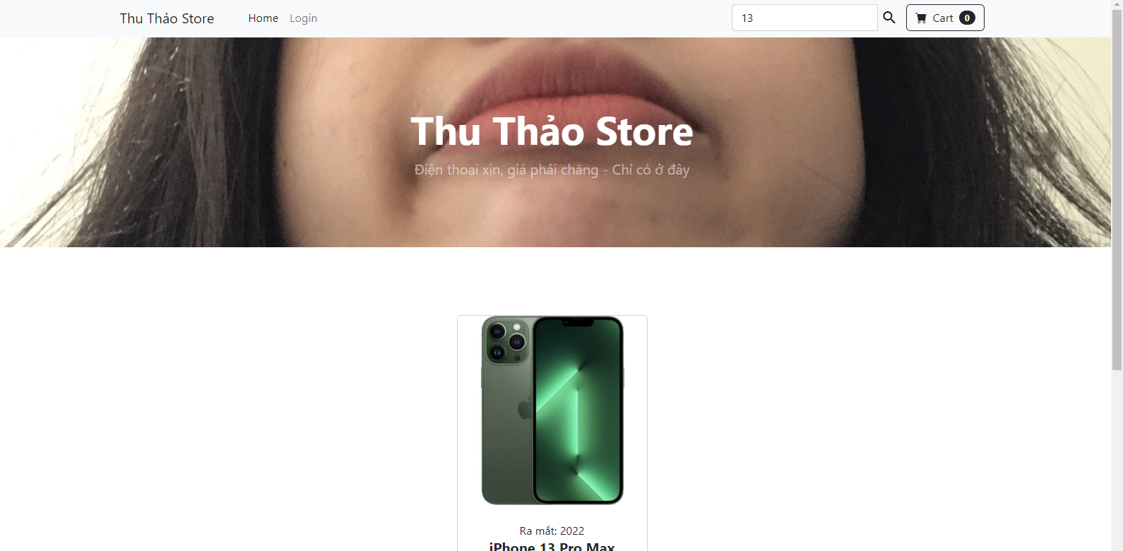

1. **Show list of products**

* Function trigger: at home page
* Function description: at home page,
* Screen layout:

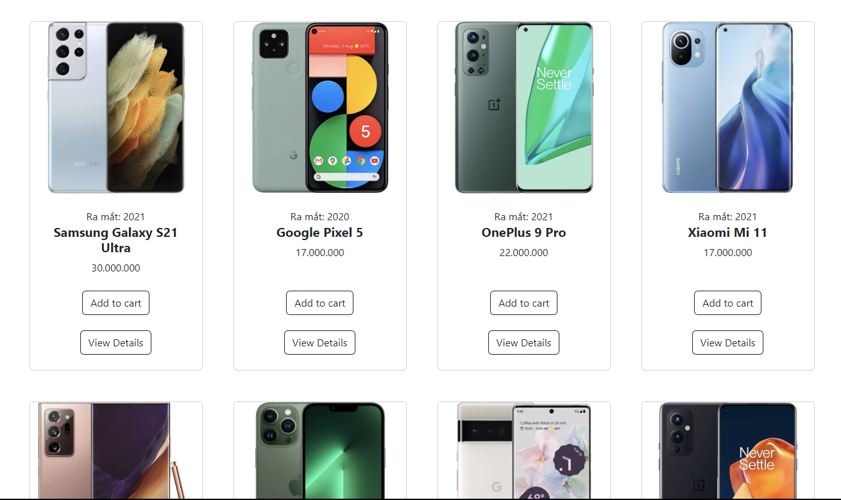

## Show details of product

* Screen layout:

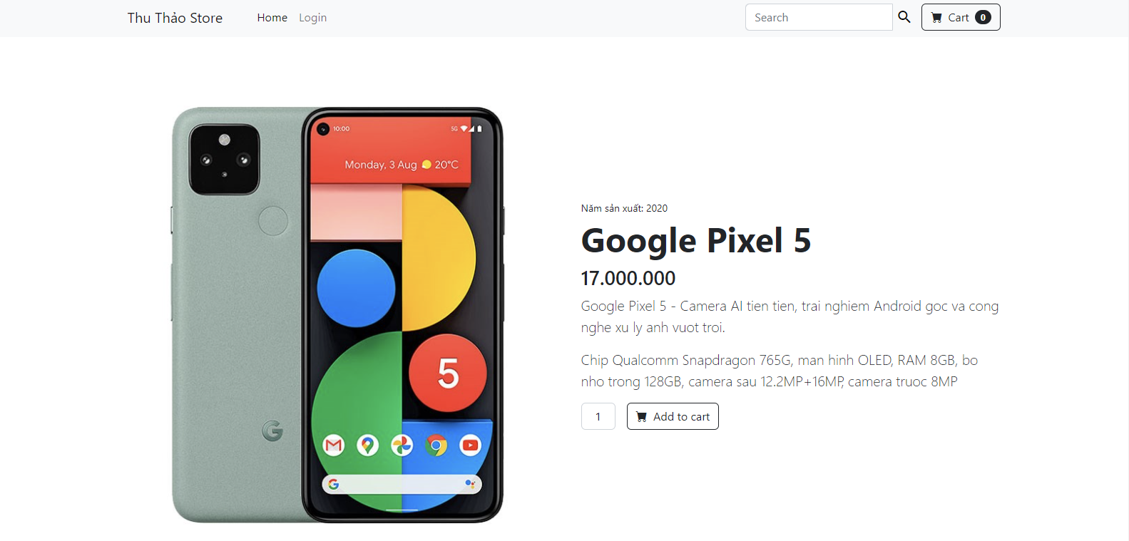

## Confirm Order

* Function trigger: after choosing view cart button
* Function description: display product information, quantites, price, total
* Screen layout:

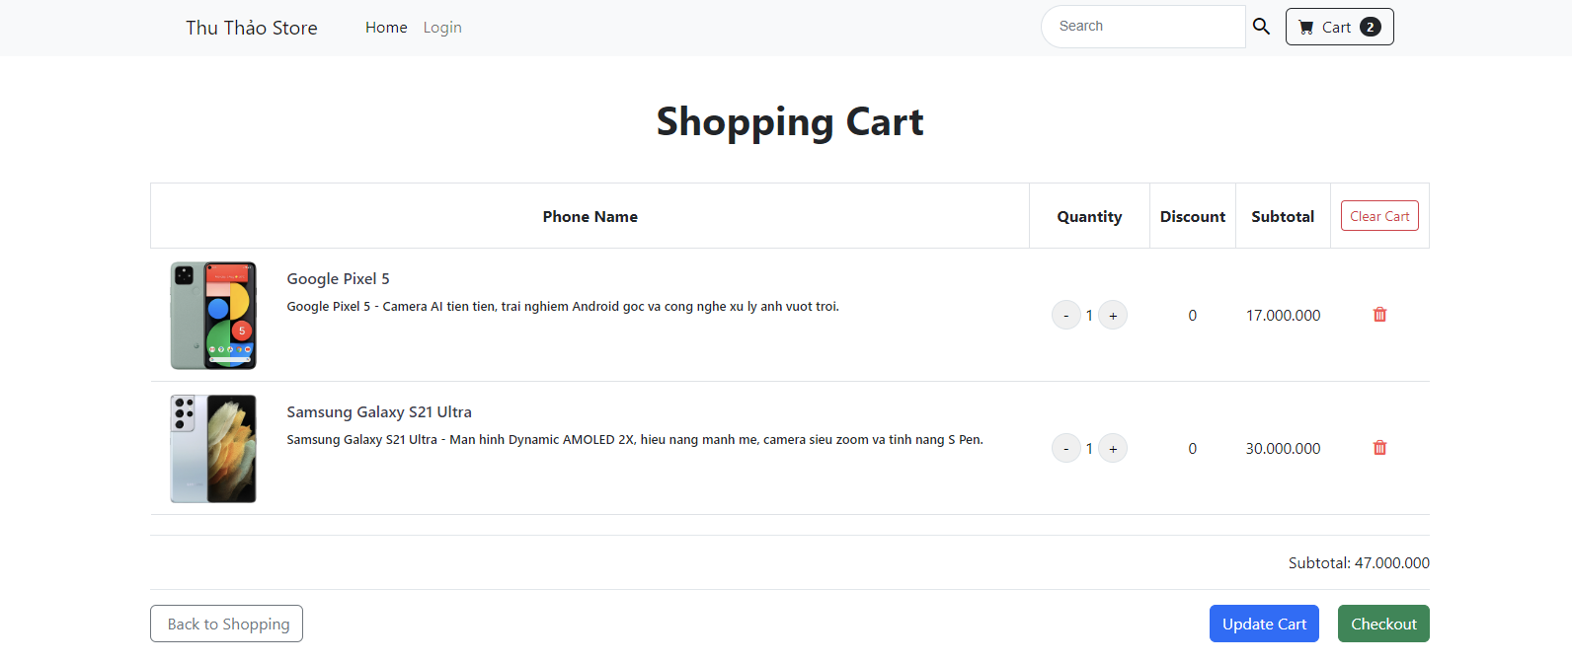

## Notice of successful order

* Function trigger: after clicking Check out
* Function description: Allows the user to enter information.
* Screen layout:

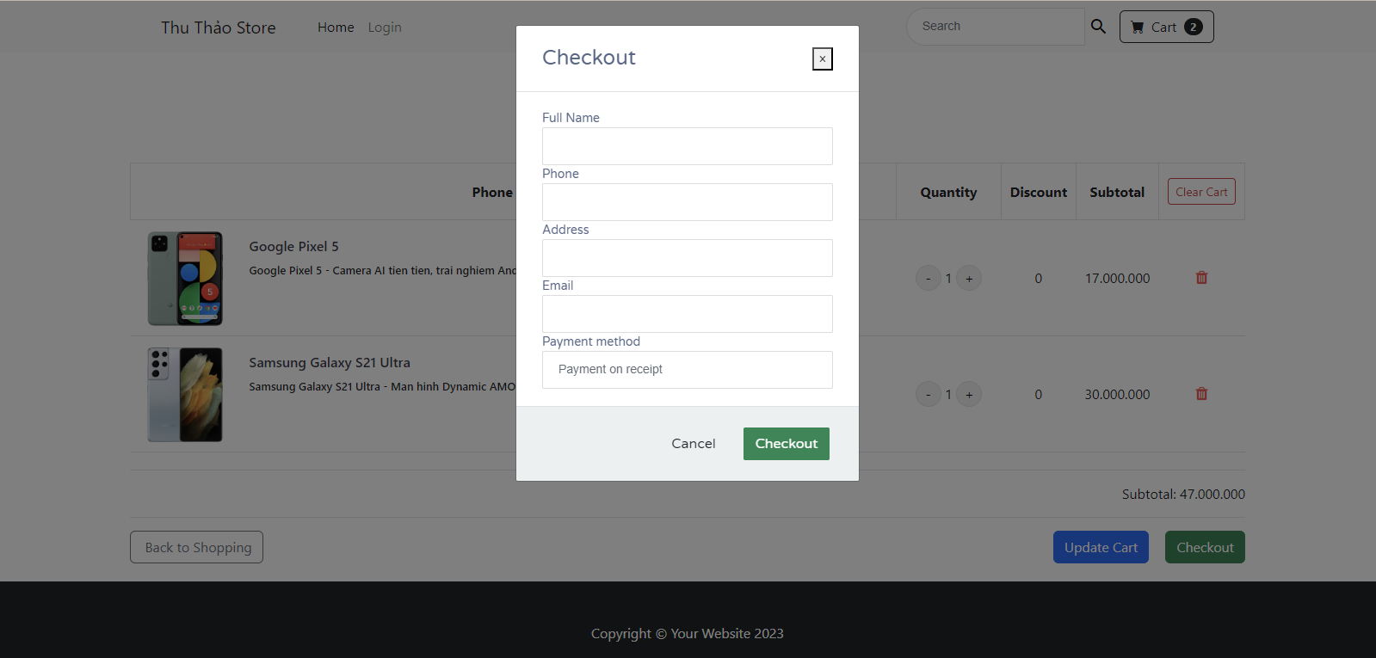

## Notice of successful order

* Function trigger: after clicking Check out
* Function description: Report an error if the information is not valid. Success if information is confirmed.
* Screen layout:

